

Program and Branch Name: B.Tech CSE (AI )
PBL Progress Report – Final
Field | Details
Course Name | Operating Systems
Course Code | CCSE0303A
Faculty Name | Dr. Varsha Jotwani, Associate Professor
Assignment Type | Group Assignment
Student(s) Name | Samar Singh  Aditi Singh  Chhavi Attri
ERP ID (I Year) / Roll No. (II Year onwards) | Samar Singh: 2501331940042  Aditi Singh: 2501331940003  Chhavi Attri: 250133194018
Team/Group No. (Group/Capstone only) | Group 7
Problem Statement / Project Title | Smart Parking Management System: an interactive simulation of Operating Systems concepts (Units 2 and 3)
SDG(s) | SDG 11: Sustainable Cities and Communities
Reporting Month | Month 3 – Final
Date of Submission | 27/10/2026

Student Declaration
I/We certify that this assignment is my/our own work, with all sources appropriately acknowledged. I/We understand that a 0% mark and further academic penalties may apply if the content is found to be plagiarised or inappropriately AI-generated.
Student Name & Signature(s): Samar Singh, Aditi Singh, Chhavi Attri ____________
Date: ____________________

2. Student Details / Team Details
Name | Roll No. | Programme and Branch | Role and contribution
Samar Singh | 2501331940042 | B.Tech CSE (AI) | Backend
Aditi Singh | 2501331940003 | B.Tech CSE (AI) | Report and documentation
Chhavi Attri | 2501331940018 | B.Tech CSE (AI) | Frontend
Group No.: 7. Faculty mentor: Dr. Varsha Jotwani, Associate Professor. Individual responsibilities were not separately assigned; the work is presented as a collective team effort.

3. Executive Summary
The Smart Parking Management System is an interactive, web-based simulation that explains Operating Systems concepts through a parking lot. Vehicles act as processes and parking slots act as shared resources. Built with a Python HTTP server and a browser dashboard, it demonstrates process management, six CPU scheduling algorithms, synchronization, Banker's Algorithm, deadlock detection and four classical synchronization problems. It is an educational prototype for Units 2 and 3; it reports implemented capabilities, not benchmark results.

4. Introduction
An operating system shares the processor and other resources among many competing programs. Students usually meet scheduling, synchronization and deadlock through definitions and static diagrams, so behaviour over time is hard to picture. This project uses a familiar situation, a parking lot, to make these ideas visible: a vehicle arrives, waits in a queue, receives a slot, stays for some time and leaves, just as a process does.
The scope is Unit 2 and Unit 3 of Operating Systems (CCSE0303A). The simulation is conceptual: the parking analogy models operating-system behaviour and does not represent CPU hardware or a deployed parking system.

5. Problem Definition
Problem statement. Concepts such as scheduling, synchronization and deadlock are abstract. Learners cannot easily observe queues changing, simultaneous requests conflicting or processes waiting in a cycle. The project must make these behaviours visible and explorable.
Objectives. Demonstrate process management and states; compare CPU scheduling algorithms and explain their metrics; demonstrate concurrency and synchronization; simulate safe resource allocation; visualize deadlock detection; and demonstrate classical synchronization problems.
Target users. Students and teachers of Operating Systems.
Constraints. A browser-based simulation; scope limited to Units 2 and 3; no performance claims without measurement.
Success criteria. Every listed concept can be run and observed on the dashboard, with correct behaviour and a clear link to the analogy.
Linked SDG. SDG 11, Sustainable Cities and Communities.

6. Industry / Application Overview
Operating Systems is usually taught with textbooks, lecture slides and exercises worked by hand. These explain algorithms accurately but are static, and the learner must imagine the timeline of events. Parking is a well-known example of a shared, limited resource, and real smart-parking systems guide drivers to free spaces; the same ideas of queues, allocation and mutual exclusion apply.
The gap addressed here is the lack of a single, interactive, analogy-based tool that covers process management, scheduling, synchronization and deadlock together for a university course. The project claims no commercial deployment; the parking scenario is used purely as a teaching device.

7. Module 1: Process Management and Parking Simulation
Concept applied. A process is a program in execution. The operating system tracks it with a Process Control Block (PCB) and moves it between New, Ready, Running, Waiting and Terminated states.
Approach. Each arriving vehicle receives a process record that plays the PCB role (the parking ticket and vehicle record). It joins the ready queue, the scheduler selects it and a slot is allocated. A vehicle that finds no free slot waits; when its simulated stay ends it terminates and releases the slot.
Work completed. The parking-yard simulation, process queues and state tracking are implemented in the Parking Yard and PCB module.
Output. Table 1 maps parking terms to OS terms and Figure 1 shows the process lifecycle.
Findings. Mapping vehicles to processes makes state changes and queue contents immediately visible, which a static diagram cannot show.
Table 1: Parking analogy and Operating Systems concepts
Parking system | Operating Systems concept
Vehicle | Process
Parking slot | Shared resource
Parking ticket and vehicle record | Process Control Block (PCB)
Waiting vehicles | Ready queue
Vehicle occupying a slot | Running process
Vehicle waiting for a free slot | Waiting (blocked) process
Gate barrier | Critical-section boundary
Slot allocation lock | Mutex
Available-slot counter | Counting semaphore
Assigning vehicles to slots | CPU scheduling and resource allocation
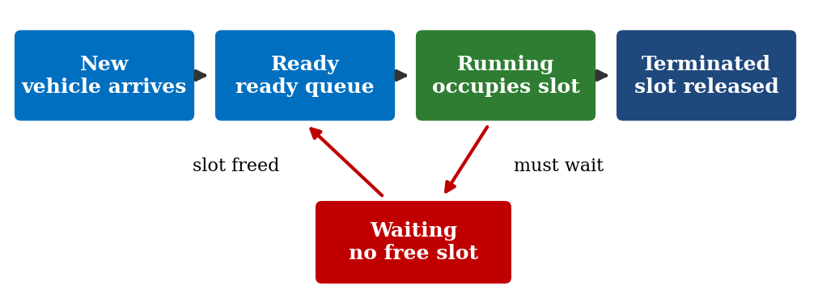
Figure 1: Process lifecycle in the parking simulation

8. Module 2: CPU Scheduling and Metrics
Concept applied. CPU scheduling decides which ready process runs next. Schedules are judged by turnaround, waiting and response time, CPU utilization and throughput.
Approach. Six algorithms are simulated on the same set of vehicles so behaviour can be compared. Decisions are drawn as a Gantt chart, and metrics follow from Turnaround = Completion − Arrival, Waiting = Turnaround − Burst and Response = First start − Arrival.
Work completed. All six algorithms, the Gantt chart and the scheduling metrics are implemented in the CPU Scheduling and Gantt Chart module.
Output. Table 2 relates each algorithm to the parking scenario.
Findings. Seeing identical arrivals scheduled differently shows how preemption, burst time and priority change waiting behaviour. No numerical comparison is reported because none was measured.
Table 2: CPU scheduling algorithms in the simulation
Algorithm | Principle | Parking view
FCFS | Arrival order; non-preemptive | First vehicle in line first
SJF | Shortest burst next; non-preemptive | Shortest stay first
SRTF | Least remaining time; preemptive | Short arrival takes the turn
Priority (non-preemptive) | Highest priority runs to completion | Priority vehicle goes next
Priority (preemptive) | Higher-priority arrival preempts | Priority vehicle interrupts
Round Robin | Fixed time quantum, circular queue | Each vehicle gets a time slice

9. Module 3: Concurrency and Synchronization
Concept applied. Several processes using a shared resource can cause a race condition, where the result depends on timing. A critical section must therefore be protected by mutual exclusion. The module covers mutex locks, Peterson's Algorithm, Test-and-Set locks and counting semaphores.
Approach. Slot allocation is treated as the critical section and the gate barrier as its boundary. Without protection, two vehicles can both read that a slot is free and both be assigned to it. With a mutex, the first vehicle locks the allocator, takes the slot and unlocks, while the second waits and then receives another slot. A counting semaphore holds the number of free slots, so vehicles wait when it reaches zero. The demonstrations use Python threading and synchronization primitives.
Work completed. Race-condition simulations and synchronization demonstrations are implemented in the Concurrency and Critical Section Lab.
Output. Table 3 contrasts the two cases.
Findings. Watching a conflicting allocation occur and then disappear once the lock is applied explains mutual exclusion more clearly than a definition does.
Table 3: Slot allocation with and without synchronization
Case | Sequence | Outcome
No lock | Cars A and B both read "Slot 5 free", both assigned | Conflict (race condition)
Mutex and semaphore | A locks, takes Slot 5, unlocks; B then locks | B receives another free slot

10. Module 4: Banker's Algorithm and Deadlock
Concept applied. Deadlock occurs when processes wait for each other forever. It requires all four Coffman conditions: mutual exclusion, hold and wait, no preemption and circular wait. The Banker's Algorithm avoids it by granting a request only if the resulting state is safe.
Approach. The module keeps the Available vector and the Allocation, Maximum and Need matrices, where Need = Maximum − Allocation. A request is checked against Need and Available, tentatively allocated, and tested by searching for a safe sequence in which every process can finish. If one exists the request is granted; otherwise the process waits. A Resource Allocation Graph shows request and assignment edges, and a cycle signals deadlock when resources have a single instance. Parking slots are the resource units and vehicles are the requesting processes.
Work completed. Banker's Algorithm, safe-sequence detection, Resource Allocation Graph display and cycle detection are implemented in the Banker's Algorithm and Deadlock module.
Output. Table 4 interprets each Coffman condition in the parking setting.
Findings. Evaluating requests before granting them shows why an unsafe state is avoided even when resources are currently free.
Table 4: Coffman conditions in the parking scenario
Condition | Parking interpretation
Mutual exclusion | A slot serves one vehicle at a time
Hold and wait | A vehicle holds one resource while waiting for another
No preemption | A held resource cannot be forcibly taken
Circular wait | A closed chain of vehicles each waits on the next

11. Module 5: Classical Synchronization Problems
Concept applied. Four classical problems capture common coordination patterns: Producer–Consumer, Reader–Writer, Sleeping Barber and Dining Philosophers.
Approach. Each problem is mapped to the parking lot, as shown in Table 5, and simulated so that the shared buffer, access rule or circular dependency can be observed. In the roundabout example, vehicles each hold one road segment while waiting for the next, producing circular waiting and a deadlock scenario.
Work completed. The four simulations are implemented in the Classical Synchronization Problems module.
Output. Table 5 gives the mapping used for each problem.
Findings. Familiar roles such as a camera, a signboard and a gatekeeper make the abstract roles of producer, reader and server easy to recognise. Each problem reuses ideas from earlier modules: mutual exclusion, bounded queues and deadlock.
Table 5: Classical problems mapped to the parking lot
Problem | Parking mapping
Producer–Consumer | Entry camera (producer), bounded waiting queue (buffer), slot allocator (consumer)
Reader–Writer | Availability signboards (readers), parking management system (writer)
Sleeping Barber | Smart gatekeeper (service provider), limited waiting chairs (queue)
Dining Philosophers | Vehicles at a roundabout competing for shared road segments

12. Final Integrated Solution / Testing and Validation
The five modules are combined in one browser dashboard served by a Python HTTP server. The dashboard (HTML, CSS, JavaScript and Three.js) sends requests to API endpoints; the simulation engine holds the process and parking-slot data models and calls the scheduling, synchronization, Banker's and classical-problem modules (Figure 2). The dashboard has six modules: Parking Yard and PCB; CPU Scheduling and Gantt Chart; Concurrency and Critical Section Lab; Banker's Algorithm and Deadlock; Classical Synchronization Problems; and Academic Report and Syllabus.
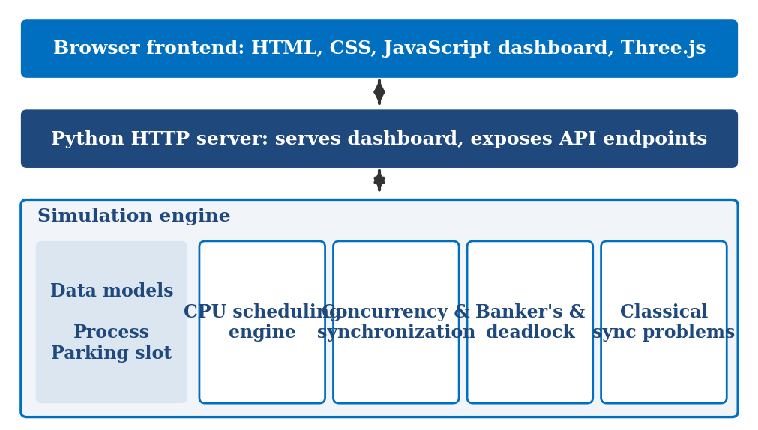
Figure 2: System architecture
Validation method. Each capability is validated by running it on the dashboard and comparing the observed behaviour with the expected behaviour from standard Operating Systems theory, as listed in Table 6. This is a demonstration-based check of correct behaviour.
Table 6: Validation approach
Capability | Check | Expected behaviour
Process states | Run a vehicle through the lifecycle | States change in order; slot is released on termination
Scheduling | Run each algorithm on the same arrivals | Gantt order matches the algorithm's rule
Metrics | Compare output with the formulas | Values follow the stated formulas
Race condition | Run with and without the lock | Conflict only without synchronization
Banker's | Submit safe and unsafe requests | Safe granted; unsafe made to wait
Deadlock | Create a circular wait | Cycle detected
Classical problems | Run all four simulations | Behaviour matches each problem's rules
Results. The implemented capabilities are demonstrated through the interactive dashboard. No benchmark, timing or performance measurements are reported or claimed.

13. Expected Benefits / Learning Outcomes
Learners who use the simulation are expected to be able to explain process states and the role of the PCB; trace how each of the six scheduling algorithms orders processes and compute turnaround, waiting and response time; describe how a race condition arises and how a mutex, semaphore, Peterson's Algorithm or Test-and-Set lock prevents it; apply the Banker's safety check and recognise a cycle in a Resource Allocation Graph; and recognise the four classical synchronization problems in everyday situations.
Wider benefits are educational. The real-world analogy lowers the barrier to abstract topics, the visual feedback supports self-study and revision, and one dashboard covers Units 2 and 3. Teachers can use it as a demonstration aid. These are expected benefits; the project has not measured learning impact. Linked to SDG 11, the parking theme also encourages students to think about shared urban resources, though the project is conceptual and not a deployed system.

14. Challenges Faced
Several design challenges arose. First, the analogy had to remain faithful: parking terms such as slots, tickets and gates had to map cleanly to processes, resources and locks, without suggesting that the simulation represents CPU hardware. Second, real race conditions depend on timing and are hard to reproduce, so the demonstration had to show the conflict clearly while still using genuine synchronization primitives to remove it.
Third, preemptive algorithms such as SRTF and preemptive Priority, and the time quantum in Round Robin, are harder to display than non-preemptive ones, so the Gantt chart had to show interruptions clearly. Fourth, Banker's Algorithm involves several vectors and matrices that must stay consistent while requests change them. Finally, six modules had to share one data model and one dashboard while staying readable. Keeping the project within Units 2 and 3, and avoiding unsupported claims about results, also required discipline.

15. Future Improvements
Possible enhancements, all proposed and not yet implemented, include additional scheduling variants, extension to other Operating Systems units such as memory management, collection of student feedback to evaluate learning impact, and export of Gantt charts and metrics as reports. Real-world integration with sensors or hardware is outside the current scope.

16. Conclusion
The Smart Parking Management System connects Operating Systems theory from Units 2 and 3 with an interactive parking simulation. By treating vehicles as processes and parking slots as shared resources, it makes process management, six CPU scheduling algorithms, synchronization, Banker's Algorithm, deadlock detection and the classical synchronization problems visible and easy to explore.
The project is an educational prototype: its outcomes are demonstrated capabilities rather than measured results. It offers a clear base for the improvements listed above and shows how a familiar scenario can make abstract topics easier to learn.

17. References
[1] A. Silberschatz, P. B. Galvin and G. Gagne, Operating System Concepts, Wiley.
[2] A. S. Tanenbaum and H. Bos, Modern Operating Systems, Pearson.
[3] W. Stallings, Operating Systems: Internals and Design Principles, Pearson.
[4] E. G. Coffman, M. J. Elphick and A. Shoshani, "System Deadlocks," ACM Computing Surveys, vol. 3, no. 2, 1971.
[5] G. L. Peterson, "Myths About the Mutual Exclusion Problem," Information Processing Letters, vol. 12, no. 3, 1981.
[6] E. W. Dijkstra, "Cooperating Sequential Processes," Technical Report EWD-123, 1965.
[7] A. N. Habermann, "Prevention of System Deadlocks," Communications of the ACM, vol. 12, no. 7, 1969.
[8] P. J. Courtois, F. Heymans and D. L. Parnas, "Concurrent Control with Readers and Writers," Communications of the ACM, vol. 14, no. 10, 1971.
[9] Python Software Foundation, Python documentation: threading module.
[10] Three.js documentation.
[11] United Nations, Sustainable Development Goal 11: Sustainable Cities and Communities.

18. Appendix: Source Code
The listings below are illustrative pseudocode of the standard algorithms the project demonstrates. They are not the project source files; selected source code can be attached in this appendix (maximum 5 pages).
// Mutex-protected slot allocation (critical section)
free_slots = Semaphore(N) // counts available slots
allocator = Mutex()
on vehicle_arrives(v):
free_slots.wait() // block if no slot is free
allocator.lock()
s = first_free_slot(); assign(v, s)
allocator.unlock()
on vehicle_leaves(v):
release(v.slot); free_slots.signal()

// Banker's safety check
Work = Available; Finish[i] = false for all i
repeat:
find i with Finish[i] == false and Need[i] <= Work
if found: Work = Work + Allocation[i]; Finish[i] = true
until none found
state is SAFE if all Finish[i] are true, else UNSAFE

